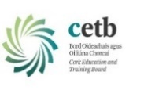
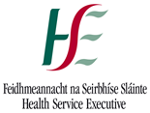
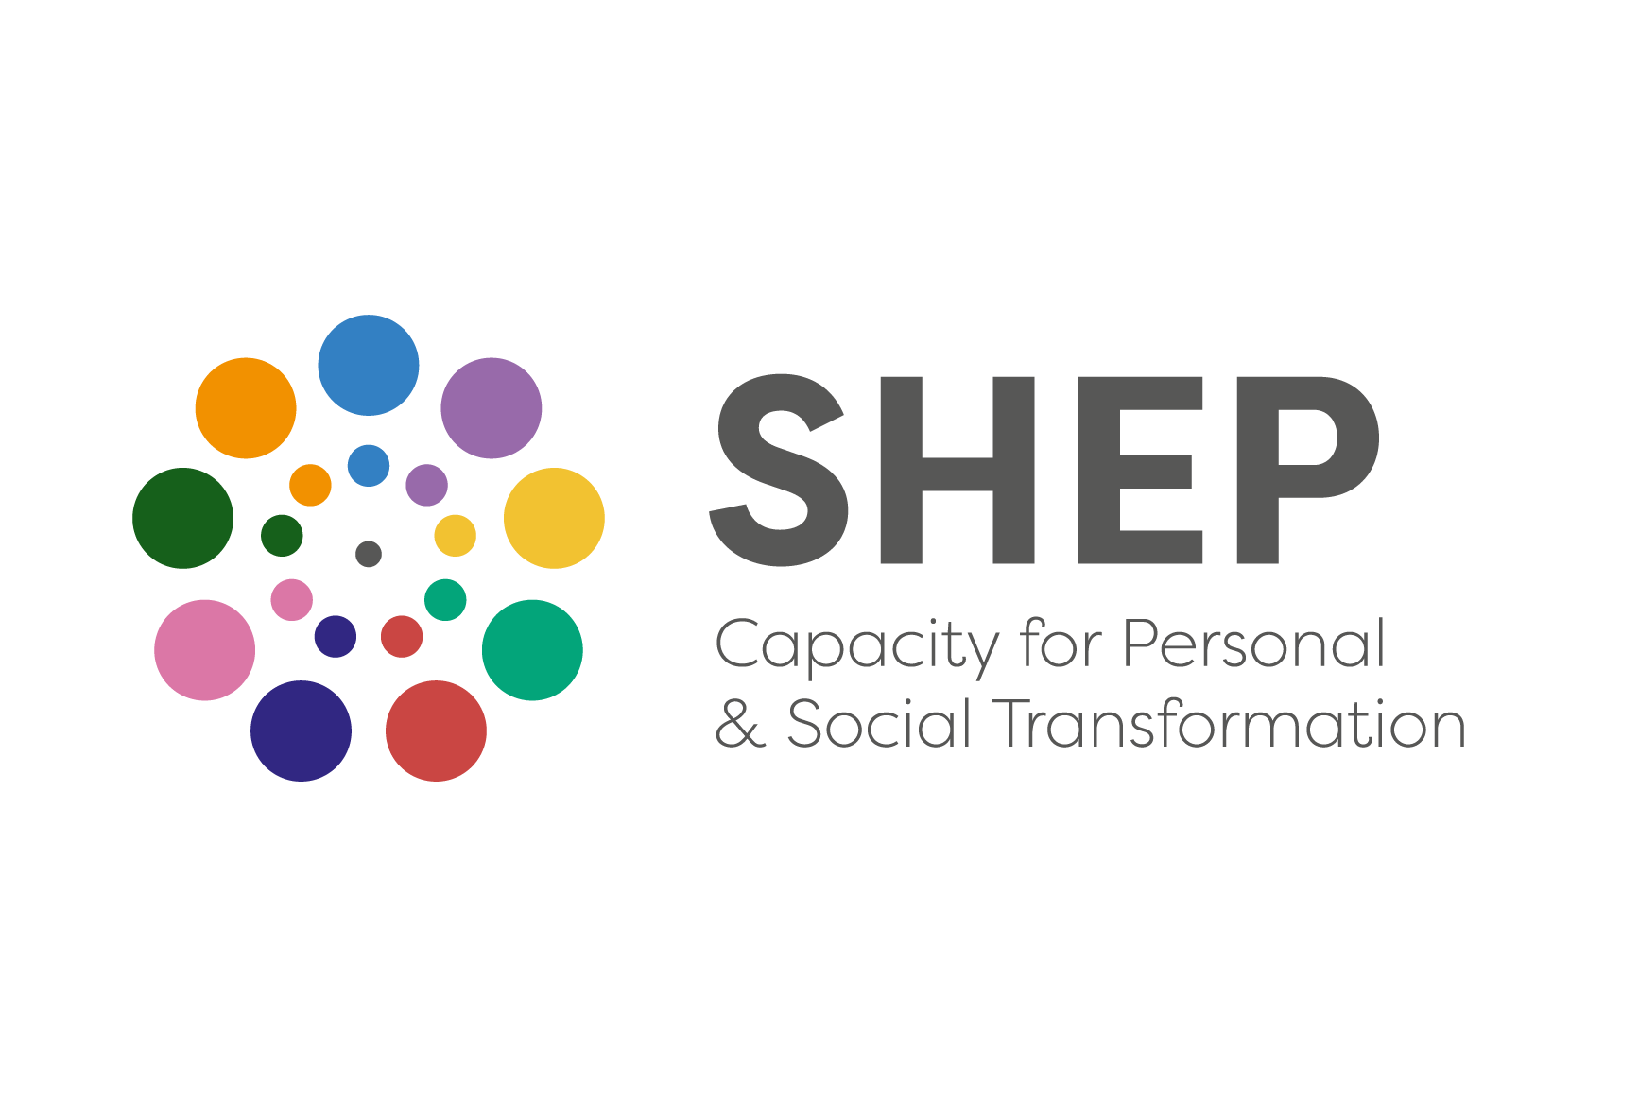
THE SHEP CERTIFICATE IN SOCIAL AWARENESS AND COMMUNITY EMPOWERMENT (SACE)
APPLICATION FORM (COURSE REF CN3926)
CORK AREA Spring 2025

SHEP Foundation Part II (SACE)
‘Training for Transformation’
Renewing You, Your Community, Your World

This application form is for the Cork SHEP Certificate in Social Awareness and Community Empowerment (SACE) ‘Training for Transformation’ course in SHEP Project Centre, Ardfoyle, Ballintemple, Cork City. It will consist of five non-residential weekend workshops between Jan and March 2025. This course is open:

- To people who have already completed SHEP’s Certificate in Personal Development, this course being Part Two of the SHEP Foundation Program in Social and Personal Health Education. For these, it is a continuation of their personal journey of growth and development, through deepening awareness of the wider social relationships with which we are all involved.
- To people from the twenty-eight Cork area Community Gardens. This year SHEP and Green Spaces for Health have secured funding to facilitate access for a number of people from the Cork-City garden communities to undertake the program towards developing community building and leadership capacities and who want to bring deeper awareness to that involvement.

The course is delivered in-person over five non-residential weekends, totaling 78 hours.
- The course fee this autumn is €550
- This is the same as in 2022. All SHEP courses are subsidized by HSE core funding to the Project.
- There are limited SHEP bursaries available in Autumn and these need to be applied for
- Please see the Reduced Rate Fee information below for eligibility
- Where awarded the bursary reduces the fee to €250 (i.e. on award of bursary of €300)
- There is no booking deposit.
Schedule for SACE ‘Training for Transformation’ CORK GROUP SPRING 2025 (Total 78 hours)
Venue – Bessboro Meditation Centre, Blackrock, Cork
Trainer Team - Kevin McCaughey, Abigail Joffe, Marie O’Flynn, Maria Young
Friday 17th January 2025 7pm to 10pm  Saturday 18th January 2025 10am – 5.30pm  Sunday 19th January 2025 10am – 5.30pm  Saturday 1st February 2025 10am – 5.30pm  Sunday 2nd February 2025 10am – 5.30pm  Saturday 15th February 2025 10am – 5.30pm  Sunday 16th February 2025 10am – 5.30pm | Saturday 1st March 2025 10am – 5.30pm  Sunday 2nd March 2025 10am – 5.30pm  Saturday 15th March 2025 10am – 5.30pm  Sunday 16th March 2025 10am – 5.30pm
- The course is facilitated by a team of 4 SHEP trainers (2 anchor trainers) and is Fully in-person.
- It Is 78 hours in length delivered over five non-residential weekends.
- The group will have 23 to 26 participants.
A Certificate of Successful Completion will be awarded on satisfactory completion of the course. Completion of both the SHEP Certificate in Personal Development and the SHEP Certificate in Social Awareness and Community Empowerment Foundation Courses is normally required and prioritised for entry to the SHEP’s Facilitation, Continuing Personal Development and Specialised Practitioner Training courses. This is important, and of immediate relevance for those considering progressing to SHEP’s Facilitation course in early 2025 or SHEP Tutor Training in 2025/2026. Admission to those courses will be subject to availability of places and selection will be on the basis, both of the quality of involvement in the Foundation Courses, and of the nature of the voluntary or professional work with people that applicants are engaged in (or plan to be engaged in). Priority of places is also given on the Continuing Personal Development courses, to applicants who have completed the full Foundation Prog. Part I & II.

Name of Applicant: __________________ ________________________________________________

Home Address: ____________________________ Work Address: __________________________

_________________________________________ _______________________________________

_________________________________________ _______________________________________

_________________________________________ _______________________________________

Home Phone: ______________________________ Work Phone: ____________________________

Mobile Phone: _____________________________ E-mail address: __________________________

Which address for correspondence? (Pease tick) Home:  Work: 

Date of birth: ________________ Occupation: __________________________________________

Relevant voluntary work (if any) ________________________________________________________

____________________________________________________________________________________

What is your interest in doing this course? ________________________________________________

____________________________________________________________________________________

How/where did you hear about the course? ____________________________________________________________________________________

Have you completed any previous courses on any aspect of health-education, personal development or group work? Please specify.
____________________________________________________________________________________

____________________________________________________________________________________

Do you have any special needs that we should be aware of for practical purposes? Please specify.

____________________________________________________________________________________

Is there any other information about yourself that you would like on file?
____________________________________________________________________________________
Course Fee
The total cost of the SHEP Cert in Social Awareness & Community Empowerment 2022/25 is €550. When a place is offered, and before the course begins, the fee should be paid in full. For those who wish, special arrangements may be made to spread payments over the duration of the course. Details of how to do this will be enclosed with the course place offer.

A limited number of Reduced Fee places at €250 on award of a SHEP bursary will be available for those who qualify. The number of Reduced Fee rate places will be awarded to those who meet the eligibility criteria on a first come basis. Please read carefully, the accompanying information sheet ‘Important Information on SHEP Fees, Payment Methods and Frequent Questions as it contains important information on Reduced Fee rate places and other special payment arrangements.

N.B For all places, Full Fee, Reduced Fee Rate places you are advantaged by applying early.

Please choose One.
◻ I am applying for this course on the basis that I will be paying the full fee.
or
◻ I am seeking a Reduced Fee rate place (please complete the Reduced Fee Rate Application Form)

Please Confirm
◻ I have read and I understand the ‘Important Information on SHEP Fees, Payment Methods and Frequent Questions’

◻ I understand and give my consent to how SHEP will use my personal data as outlined below (please contact the Project on 021 4666180 if you want to talk through any aspect of this)

◻ (Where applicable) I am also enclosing the completed Reduced Fee Rate Application form.

◻ I have reconciled all outstanding fees.

SHEP Mailing list
◻ Please indicate if you wish to be joined to SHEP’s ‘Mailing List’ to receive information about Project news and future programs you may have interest in. You can ‘Unsubscribe’ from the SHEP Mailing List at any time in the future.

For assistance to complete this form and/or further information phone: (021) 466 6180

Signature: ______________________________ Date: _________________________

Please return this form to the Programme Administrator preferably online to info@socialandhealth.com
Alternatively, you can post to The Programme Administrator,
SHEP, The Old Primary School, Ardfoyle Avenue, Ballintemple, Cork. T12 XDH2.
Applications Accepted up to 7th January 2025
Offers of places will issue before this date to those who have already applied (circa 22) – only a few places remain so please apply as soon as possible if interested
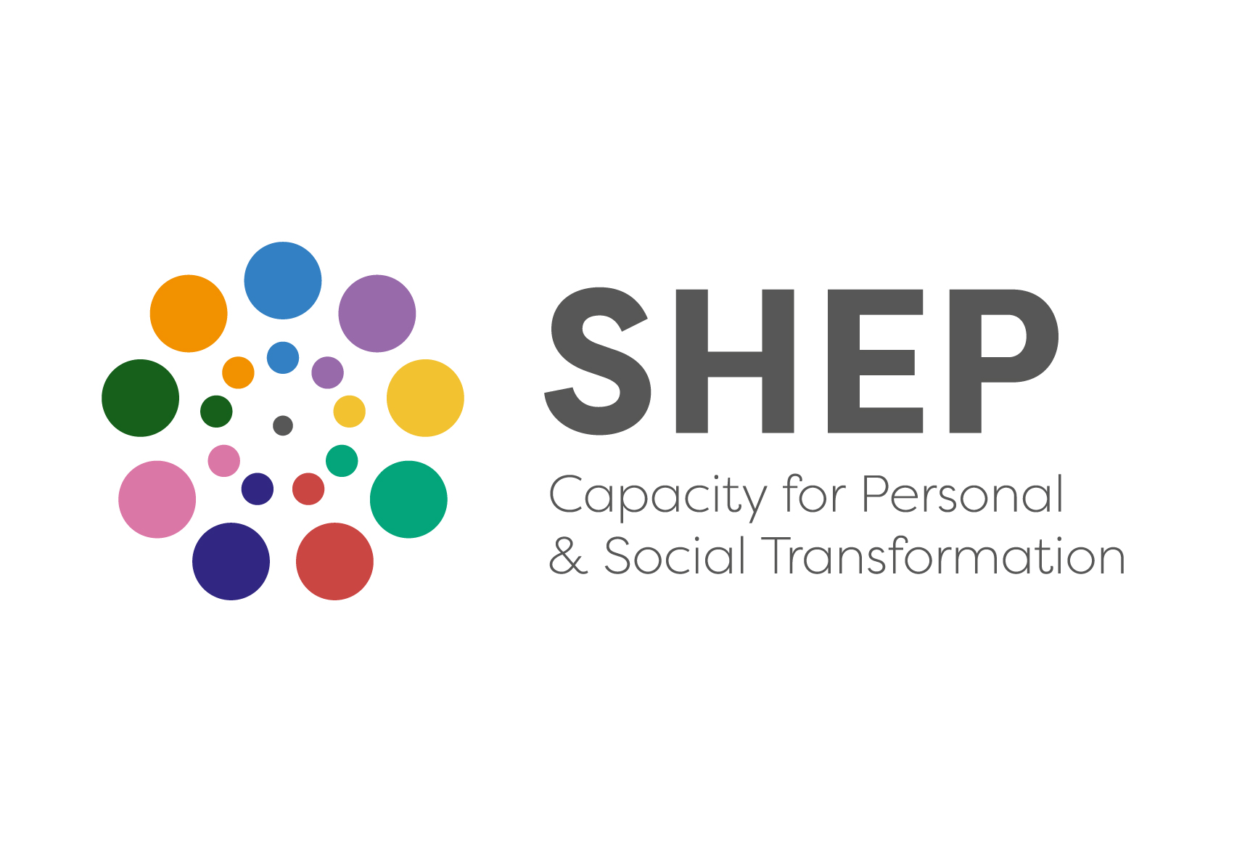
Reduced Fee Rate Application Form
2024/25 SHEP Social Awareness & Community Empowerment
‘Training for Transformation’

If you need assistance to complete this form (and/or further information) please feel free to phone us on (021) 466 6180 (Cork); 087 7728089 (Kerry); 085 8626844 (Limerick)

Name of Course you wish to apply for: _________________________________________

Location of Course you wish to apply for: _________________________________________

Name: ____________________________________ Home Phone: _________________________

Address: _____________________________________ Mobile Phone: ____________________________

_____________________________________ E-mail Address: ____________________________

SHEP offers a Reduced Fee rate for some courses.
SHEP recognises that for some people, the course fee, even though it is a subsidised fee, may still be prohibitive. To make our courses accessible we offer a Reduced Fee rate on some SHEP courses offered in Cork, Kerry and Limerick. For the Cork SACE ‘Training for Transformation’ course in Autumn/Spring 2024/2025, reduced fee rate places are supported by the SHEP Bursary Fund – where awarded a Bursary amount to €300 it reduces the course fee payable to €250. Only a limited number of bursaries are available.

If you intend to submit this application, please read our information document ‘Important Information on SHEP Fees, Reduced Fee Rate fees & Frequent Questions’.

Eligibility for a SHEP Reduced Fee Rate place
You may apply for a SHEP Reduced Fee rate if you are: (i) a social welfare recipient* (ii) are eligible for support provided by the MWRDAF support to the SHEP programme in Counties Limerick, Clare and Tipperary, or (iii) a full-time student or (iv) if you are experiencing financial hardship.

*You may apply to SHEP for the SHEP Reduced Fee rate place if you are in receipt of one of the following Social Welfare benefits/allowances:
- Blind Person’s Allowance  - Carer’s Allowance  - Carer’s Benefit  - Disability Allowance  - Working Family Payment  - Farm Assist | - Illness Benefit  - Invalidity Pension  - Job Seeker’s Allowance  - Job Seeker’s Benefit  - One Parent Family Payment
We cannot guarantee, that all applicants will be successful. SHEP Reduced Fee Rate places will be awarded to those who meet the eligibility criteria on a ‘first-come, first–served’ basis. Early applications therefore have an advantage.

If you need assistance to complete this section, please feel free to phone us on (021) 466 6180

OPTION: ◻ SHEP REDUCED FEE RATE FEE
I am applying for a SHEP REDUCED FEE rate, on the basis that:

I am a Social Welfare recipient: ◻ Name of Payment: _______________________________
I am a full-time student: ◻ Name of Course & College: __________________________
I am experiencing financial hardship. ◻ Please set out your case separately in letter.

- If a Reduced Fee rate fee is not available to me, I am willing to pay the full fee. ◻
- If a Reduced Fee rate fee is not available to me and I am not able to pay the full fee I will withdraw my application for a course place. ◻

Please confirm that you are enclosing the following: (Please tick)

◻ I am enclosing my course application form.
◻ I am enclosing evidence of the Social Welfare payment being made to me (where relevant) or (if not in receipt of Social Welfare a letter setting out the case for a reduced fee rate award)

I understand that the information provided here will be used in determining whether I am to be offered a place.

Signature: ______________________________________ Date: _______________________

When completed please return this form, along with the required supporting documents, and the application form, to

The Programme Administrator, preferably online to info@socialandhealth.com

Alternatively, you can post to The Programme Administrator,
The Social & Health Education Project,
Old Primary School, Ardfoyle Avenue,
Ballintemple, Cork. T12 XDH2

Applications Accepted up to 7th January 2025
Offers of places will issue before this date to those who have already applied (circa 22) – only a few places remain so please apply as soon as possible if interested

How will SHEP use Personal Data of course participants?
SHEP asks only for the minimum information from course applicants, sufficient enough to process applications and course participations. You have rights in relation to your own personal information used by SHEP, including the right to object to processing and right of access to your own personal information. We genuinely encourage you, if you have any queries or concerns about how your personal data will used or stored, to talk with SHEP training staff on 021 4666180 or email us at info@socialandhealth.com. SHEP’s purposes for gathering information are:

- To contact you about your application.
- To follow up with you after the application is received and administer your application as required.
- To manage course processes (including commencement, completion, progressions, course payments where relevant, course evaluations, project statistical reporting).
- To maintain your participant training record (including personal & course details)
- To share information with course facilitators, organisations involved collaboratively in courses, or where there is a fee funding support being sought. Only necessary information is shared and SHEP will be transparent with you.
- Where information is to be disclosed beyond the purpose above, specific additional consent will be sought from you.

Participant information is stored on secure, protected cloud based and in-house specialized training and education database. Hard copy information is stored in secured cabinets. Information is only accessed for the above purposes and only accessed by authorized SHEP training, administration and accounts staff.

As an applicant for one of SHEP’s courses, we ask that you read and understand the above data protection statement and application form carefully. On this application form we need your signature to:
- Confirm that you have read, understood and give consent to how SHEP will store, use and access the personal information you provide.
- Indicate if you wish to be joined onto our ‘Mailing List’ to receive information about Project news and future programs you may have interest in

We are committed to ensuring that any information we collect is handled in accordance with the principles set out in the General Data Protection Regulation (Regulation (EU) 2016/679) and the Data Protection Acts 1988 to 2018. SHEP’s detailed Data Protection Policy and time scales for retention of information is available at www.socialandhealth.com.

