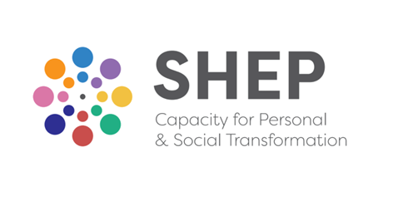
Social and Health Education Project CLG (SHEP) is a Community Education & Development Project established in 1974. In solidarity and partnership with others we seek to foster the well-being of people, families, communities and the wider world and to contribute to building a healthy, loving, socially just and sustainable way of living. We are core-funded by the HSE (Section 39).

Training & Development Officer

(Personal Development) – half-time

Owing to a forthcoming staff retirement, we are now inviting applications for this part-time position based at SHEP’s main office and training centre at Ardfoyle, Ballintemple, Cork. Flexible working arrangements and some remote working can be negotiated. The Training and Development Officer will have responsibility for the support and development of a number of key elements of SHEP’s core Personal Development training programme.

We are looking for a suitably qualified candidate with: accredited membership of IACP and/or IAHIP; personal commitment to values which are compatible with the values and ethos of SHEP; a minimum of four years’ relevant work experience, significant training in, and experience of facilitating experiential (personal development) group-work; excellent interpersonal skills and proven organisational skills. Knowledge of SHEP’s training programme would be a distinct advantage.

For details and an application form visit our website www.socialandhealth.com. Closing date for applications is Friday 28th February 2025. First interviews to take place on Tuesday 18th March. Shortlisting will apply. A panel may be created from which future vacancies may be filled.

SHEP is an Equal Opportunities Employer

