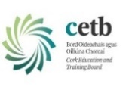
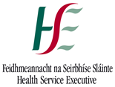
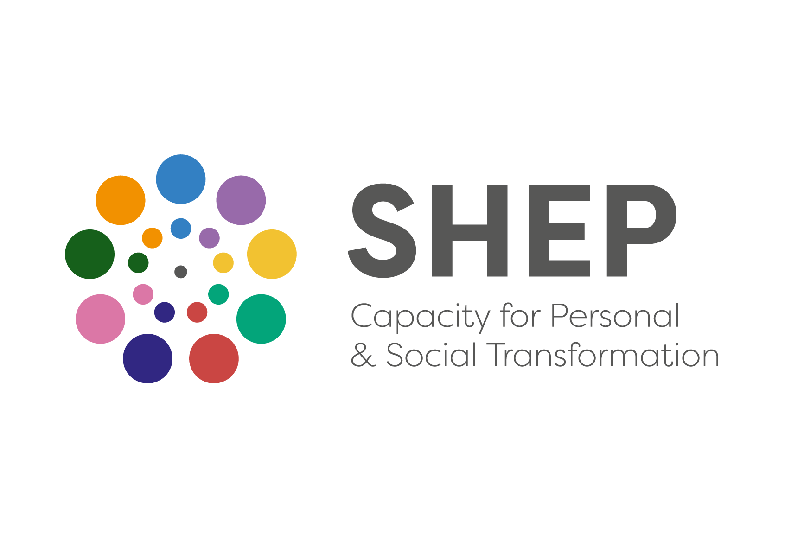
THE SHEP CERTIFICATE IN SOCIAL AWARENESS AND COMMUNITY EMPOWERMENT (SACE)
APPLICATION FORM (COURSE REF CN004013)
CORK AREA AUTUMN 2025

SHEP Foundation Part II (SACE)
‘Training for Transformation’
Renewing You, Your Community, Your World

This application form is for the Cork SHEP Certificate in Social Awareness and Community Empowerment (SACE) ‘Training for Transformation’ course. The course will run in the Bessboro, Meditation Centre, Blackrock, Cork (Eircode T12 D922). It will consist of five non-residential weekend workshops between September and November 2025. This course is open:

- To people who have already completed SHEP’s Certificate in Personal Development, this course being Part Two of the SHEP Foundation Program in Social and Personal Health Education. For these, it is a continuation of their personal journey of growth and development, through deepening awareness of the wider social relationships with which we are all involved.
- To people from the twenty-eight Cork area Community Gardens. This year again SHEP and Green Spaces for Health have sought funding to facilitate access for a number of people from the Cork-City Garden communities to undertake the program towards developing community building and leadership capacities and who want to bring deeper awareness to that involvement.
- To people from Community who would like to explore their experiences of engaging with the themes explored in the course. using an experiential learning groupwork approach.

The course is run in-person over five non-residential weekends, totaling 78 hours.
- The course fee this autumn is €550
Schedule for SACE ‘Training for Transformation’ CORK GROUP AUTUMN 2025 (Total 78 hours)
Venue – Bessboro Meditation Centre, Blackrock, Cork Eircode T12 D922
Trainer Team - Kevin McCaughey, Abigail Joffe, Marie O’Flynn, Michael O’Donnell & Maria Young
Friday 19th September 2025 7pm to 10pm  Saturday 20th September 2025 10am – 5.30pm  Sunday 21st September 2025 10am – 5.30pm  Saturday 4th October 2025 10am – 5.30pm  Sunday 5th October 2025 10am – 5.30pm  Saturday 18th October 2025 10am – 5.30pm  Sunday 19th October 2025 10am – 5.30pm | Saturday 1st November 2025 10am – 5.30pm  Sunday 2nd November 2025 10am – 5.30pm  Saturday 15th November 2025 10am – 5.30pm  Sunday 16th November 2025 10am – 5.30pm
- This is the same as in 2022 and recent years. All SHEP courses are subsidized by HSE core funding to the Project.
- There is no booking deposit.
- There are no SHEP bursaries available this Autumn as unfortunately the Bursary Fund is depleted.
- The course is facilitated by a team of 5 SHEP trainers and is Fully in-person.
- It Is 78 hours in length delivered over five non-residential weekends.

The group will have 23 to 26 participants. A Certificate of Successful Completion will be awarded on satisfactory completion of the course. Completion of both the SHEP Certificate in Personal Development and the SHEP Certificate in Social Awareness and Community Empowerment Foundation Courses is normally required and prioritised for entry to the SHEP’s Facilitation, Continuing Personal Development and Specialised Practitioner Training courses. This is important, and of immediate relevance for those considering progressing to SHEP’s Facilitation course, Continuing Personal Development course in early 2026 or SHEP’s next Tutor Training in Autumn 2026. Admission to those courses will be subject to availability of places and selection will be on the basis, both of the quality of involvement in the two Foundation Courses, and of the nature of the voluntary or professional work with people that applicants are engaged in (or plan to be engaged in). Priority of places is also given on the Continuing Personal Development courses, to applicants who have completed the full Foundation Prog. Part I & II.

Name of Applicant: __________________ ________________________________________________

Home Address: ____________________________ Work Address: __________________________

_________________________________________ _______________________________________

_________________________________________ _______________________________________

_________________________________________ _______________________________________

Home Phone: ______________________________ Work Phone: ____________________________

Mobile Phone: _____________________________ E-mail address: __________________________

Which address for correspondence? (Pease tick) Home:  Work: 

Date of birth: ________________ Occupation: __________________________________________

Relevant voluntary work (if any) ________________________________________________________
____________________________________________________________________________________

What is your interest in doing this course? ________________________________________________

____________________________________________________________________________________

How/where did you hear about the course? ____________________________________________________________________________________
Have you completed any previous courses on any aspect of health-education, personal development or group work? Please specify.
____________________________________________________________________________________

____________________________________________________________________________________

Do you have any special needs that we should be aware of for practical purposes? Please specify.

____________________________________________________________________________________

Is there any other information about yourself that you would like on file?
____________________________________________________________________________________

Course Fee
The total cost of the SHEP Cert in Social Awareness & Community Empowerment 2025 is €550. When a place is offered, and before the course begins, the fee should be paid in full. For those who wish, special arrangements may be made to spread payments over the duration of the course. Details of how to do this will be enclosed with the course place offer.

N.B You are advantaged by applying early.

Please choose One.
◻ I am applying for this course on the basis that I will be paying the full fee.

Please Confirm
◻ I have read and I understand the ‘Important Information on SHEP Fees, Payment Methods and Frequent Questions’

◻ I understand and give my consent to how SHEP will use my personal data as outlined below (please contact the Project on 021 4666180 if you want to talk through any aspect of this)

◻ I have reconciled all outstanding fees.

SHEP Mailing list
◻ Please indicate if you wish to be joined to SHEP’s ‘Mailing List’ to receive information about Project news and future programs you may have interest in. You can ‘Unsubscribe’ from the SHEP Mailing List at any time in the future.

For assistance to complete this form and/or further information phone: (021) 466 6180

Signature: ______________________________ Date: _________________________

Please return this form to the Programme Administrator preferably online to info@socialandhealth.com
Alternatively, you can post to The Programme Administrator,
SHEP, The Old Primary School, Ardfoyle Avenue, Ballintemple, Cork. T12 XDH2.

Applications Accepted up to Friday 29th August 2025

Offers of places will issue before this date if we have sufficient applicants to form a group of circa 22. Please apply as soon as possible to avoid being on a waiting list.
How will SHEP use Personal Data of course participants?
SHEP asks only for the minimum information from course applicants, sufficient enough to process applications and course participations. You have rights in relation to your own personal information used by SHEP, including the right to object to processing and right of access to your own personal information. We genuinely encourage you, if you have any queries or concerns about how your personal data will used or stored, to talk with SHEP training staff on 021 4666180 or email us at info@socialandhealth.com. SHEP’s purposes for gathering information are:

- To contact you about your application.
- To follow up with you after the application is received and administer your application as required.
- To manage course processes (including commencement, completion, progressions, course payments where relevant, course evaluations, project statistical reporting).
- To maintain your participant training record (including personal & course details)
- To share information with course facilitators, organisations involved collaboratively in courses, or where there is a fee funding support being sought. Only necessary information is shared and SHEP will be transparent with you.
- Where information is to be disclosed beyond the purpose above, specific additional consent will be sought from you.

Participant information is stored on secure, protected cloud based and in-house specialized training and education database. Hard copy information is stored in secured cabinets. Information is only accessed for the above purposes and only accessed by authorized SHEP training, administration and accounts staff.

As an applicant for one of SHEP’s courses, we ask that you read and understand the above data protection statement and application form carefully. On this application form we need your signature to:
- Confirm that you have read, understood and give consent to how SHEP will store, use and access the personal information you provide.
- Indicate if you wish to be joined onto our ‘Mailing List’ to receive information about Project news and future programs you may have interest in

We are committed to ensuring that any information we collect is handled in accordance with the principles set out in the General Data Protection Regulation (Regulation (EU) 2016/679) and the Data Protection Acts 1988 to 2018. SHEP’s detailed Data Protection Policy and time scales for retention of information is available at www.socialandhealth.com.

